New Feature Apps Ticketing HGT Services Indonesia

1. Monitoring progress on real-time

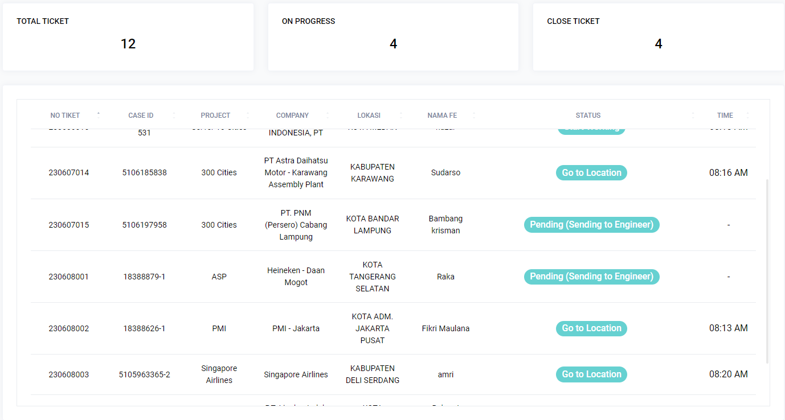

1. Specific Information in manage ticket

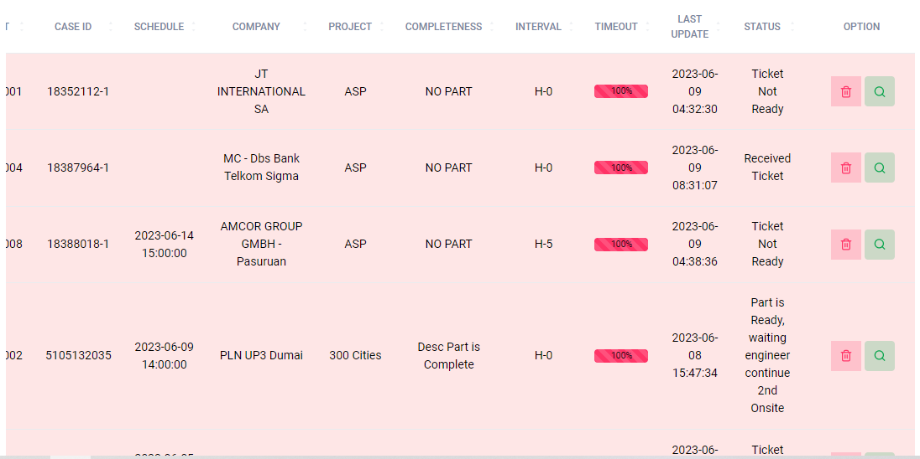

1. Detil Report

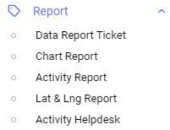

1. Data Report Ticket (Rawr Data) with looks new

1. get Activity Engineer & Location

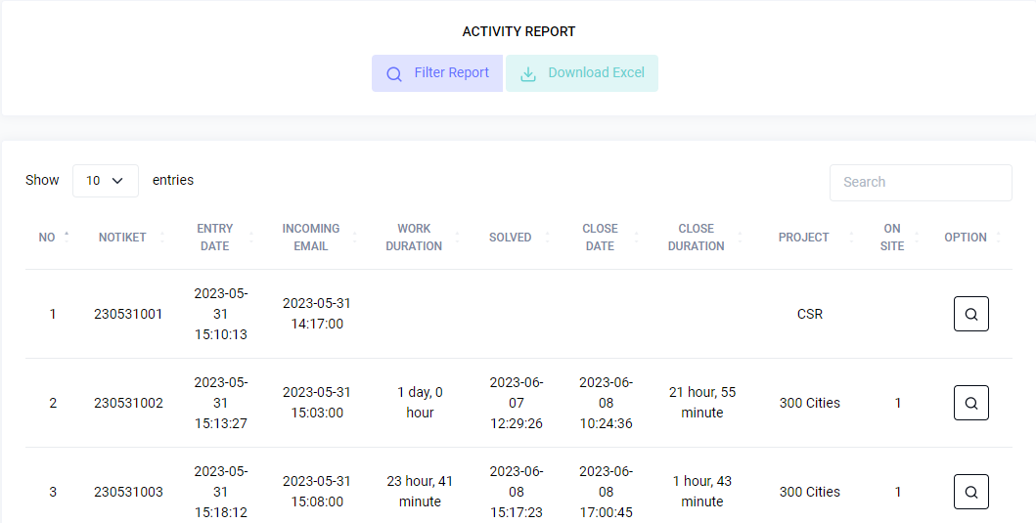

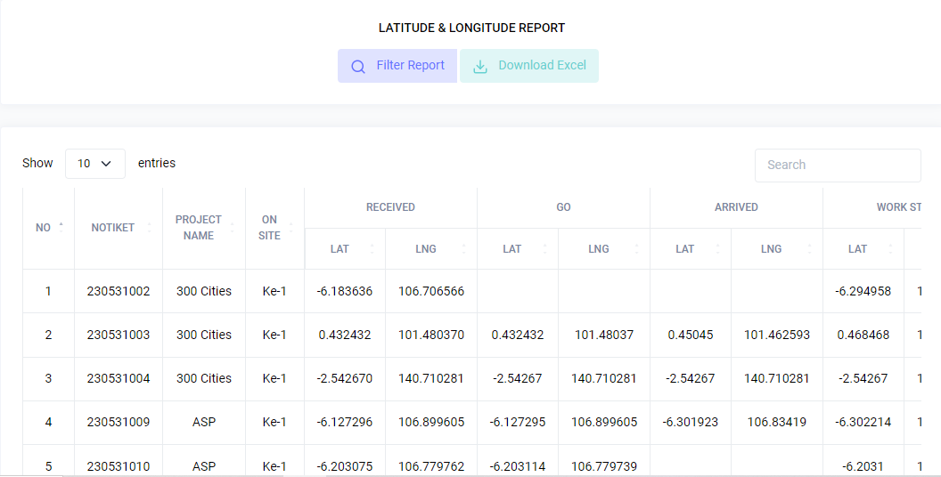

1. Activity Helpdesk

